Branch

What is Branch in Version Control?
# Source: AI Source: Provided by: [Data Path: Persons Table -> ID Column: 1, Name_En Column: Motasem Essam] -> From: [ChatGPT] on [2/15/2026]
A branch in Git is a pointer to a specific commit, representing an independent line of development in your project.
Think of a branch as a parallel timeline that allows you to work on features or fixes without affecting the main code.

Key points about branches
# Source: AI Source: Provided by: [Data Path: Persons Table -> ID Column: 1, Name_En Column: Motasem Essam] -> From: [ChatGPT] on [2/15/2026]
- Branches point to commits
  - A branch stores a pointer to the latest commit in that line of development.
  - Example: main branch points to the latest commit on the main timeline.
- You can have multiple branches
  - Each branch represents a different development path.
  - Example: feature-login, bugfix-header, etc.
- HEAD points to the current branch
  - The branch you are working on determines where your new commits go.
- Branches are cheap and fast
  - Git uses pointers, not copies of the project, so creating or switching branches is very fast.

Example
# Source: AI Source: Provided by: [Data Path: Persons Table -> ID Column: 1, Name_En Column: Motasem Essam] -> From: [ChatGPT] on [2/15/2026]
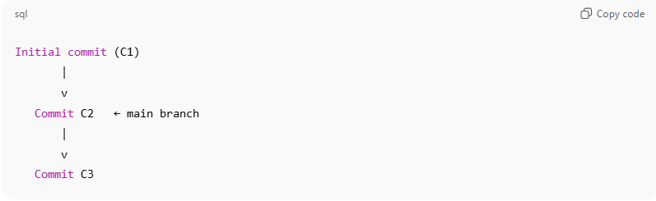
Initial commit (C1)
|
v
Commit C2 ← main branch
|
v
Commit C3
Create a new branch for a feature:
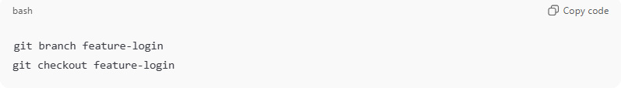
git branch feature-login
git checkout feature-login
Now your history:
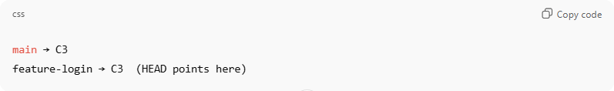
main → C3
feature-login → C3 (HEAD points here)
- Any new commits on feature-login won’t affect main until you merge.

Common commands
# Source: AI Source: Provided by: [Data Path: Persons Table -> ID Column: 1, Name_En Column: Motasem Essam] -> From: [ChatGPT] on [2/15/2026]
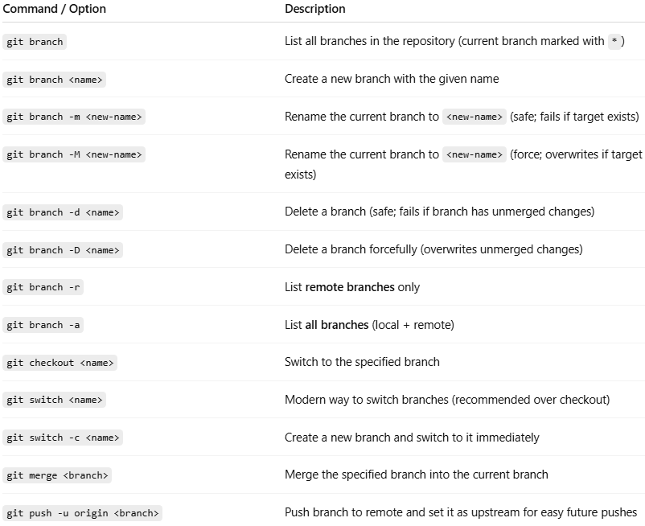
Command / Option | Description
git branch | List all branches in the repository (current branch marked with *)
git branch <name> | Create a new branch with the given name
git branch -m <new-name> | Rename the current branch to <new-name> (safe; fails if target exists)
git branch -M <new-name> | Rename the current branch to <new-name> (force; overwrites if target exists)
git branch -d <name> | Delete a branch (safe; fails if branch has unmerged changes)
git branch -D <name> | Delete a branch forcefully (overwrites unmerged changes)
git branch -r | List remote branches only
git branch -a | List all branches (local + remote)
git checkout <name> | Switch to the specified branch
git switch <name> | Modern way to switch branches (recommended over checkout)
git switch -c <name> | Create a new branch and switch to it immediately
git merge <branch> | Merge the specified branch into the current branch
git push -u origin <branch> | Push branch to remote and set it as upstream for easy future pushes

💡 Notes:
- -m vs -M → Use -M if you want to rename even if the branch already exists.
- git switch is the modern replacement for git checkout when changing branches.
- git branch -d will prevent accidental deletion of branches that haven’t been merged.

Analogy
# Source: AI Source: Provided by: [Data Path: Persons Table -> ID Column: 1, Name_En Column: Motasem Essam] -> From: [ChatGPT] on [2/15/2026]
- Think of a branch as a road in a map:
  - main = main highway
  - feature-login = side road you can explore without disturbing the main path
- HEAD = your current location on that road

💡 Memory trick:
# Source: AI Source: Provided by: [Data Path: Persons Table -> ID Column: 1, Name_En Column: Motasem Essam] -> From: [ChatGPT] on [2/15/2026]
Branch = a named pointer to a commit → a separate line of development

